Lab-3

1.

Code :-

using System;

namespace Program

{

    class MainClass

    {

        public static void Main(string[] args)

        {

            Console.WriteLine("Please Enter Numerator : ");

            int num = int.Parse(Console.ReadLine() ?? throw new Exception());

            Console.Write("Please Enter Denominator : ");

            int deno = int.Parse(Console.ReadLine() ?? throw new Exception());

            int q = num / deno;

            int r = num % deno;

            double f = (float)num / (float)deno;

            //For Rounding double digits

            f = Math.Round(f, 2);

            Console.WriteLine($"Intger division result : {q} with remainder {r}");

            Console.WriteLine($"Floating point division result : {f}");

            Console.WriteLine($"The result of mixed fraction : {q} {r}/{deno}");

        }

    }

}

Output :- 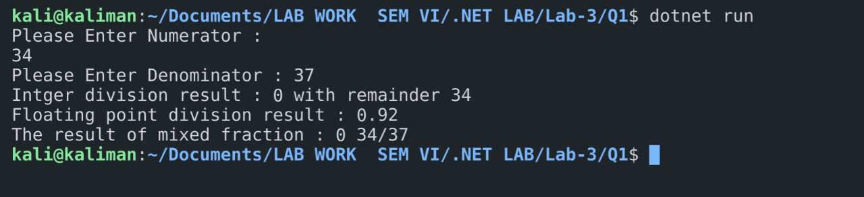

2.

Code :-

using System;

namespace Program

{

    class StringManipulation

    {

        public static void Main(String[] args)

        {

            //length of string

            Console.WriteLine("1. Enter any String : - ");

            string str = Console.ReadLine() ?? throw new Exception();

            int len = str.Length;

            Console.WriteLine($"The length of string {str} is {len} .");

            //find type of sentence

            Console.WriteLine("2. Enter Sentence :- ");

            string sentence = Console.ReadLine() ?? throw new Exception();

            StringManipulation.checkSentence(sentence);

            //first and last name

            Console.WriteLine("3. Enter Your Full Name : ");

            string name = Console.ReadLine() ?? throw new Exception();

            int space = name.IndexOf(" ");

            string fname = name.Substring(0, space);

            string lname = name.Substring(space);

            Console.WriteLine($"{lname} , {fname}");

        }

        public static void checkSentence(string s)

        {

            if (s.EndsWith("."))

                Console.WriteLine("Above Sentence Is Declarative ");

            else if (s.EndsWith("?"))

                Console.WriteLine("Above Sentence Is Interogatory ");

            else if (s.EndsWith("!"))

                Console.WriteLine("Above Sentence Is Exclaimatory ");

            else

                Console.WriteLine("Above Sentence Is Something else ");

        }

    }

}

Output:-

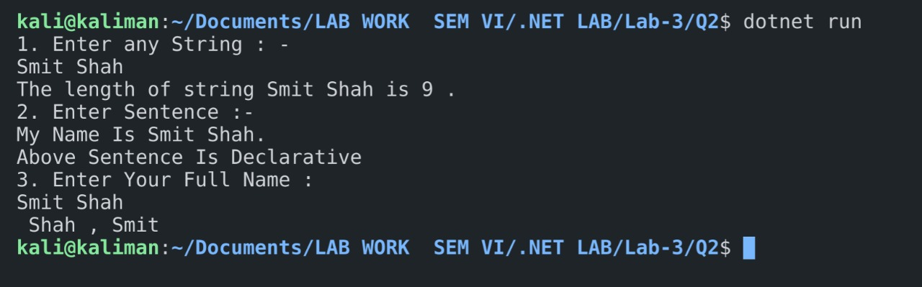

3.

Code:-

using System;

namespace Enumeration

{

    public enum Days

    {

        None = 0b_0000_0000, // 0

        Monday = 0b_0000_0001, // 1

        Tuesday = 0b_0000_0010, // 2

        Wednesday = 0b_0000_0100, // 4

        Thursday = 0b_0000_1000, // 8

        Friday = 0b_0001_0000, // 16

        Saturday = 0b_0010_0000, // 32

        Sunday = 0b_0100_0000, // 64

        Weekend = Saturday | Sunday

    }

    public class Enum

    {

        public static void Main(String[] arg)

        {

            Days meetingDays = Days.Monday | Days.Wednesday | Days.Friday;

            Console.WriteLine(meetingDays);

            // Output:

            // Monday, Wednesday, Friday

            Days workingFromHomeDays = Days.Thursday | Days.Friday;

            Console.WriteLine($"Join a meeting by phone on {meetingDays & workingFromHomeDays}");

            // Output:

            // Join a meeting by phone on Friday

            bool isMeetingOnTuesday = (meetingDays & Days.Tuesday) == Days.Tuesday;

            Console.WriteLine($"Is there a meeting on Tuesday: {isMeetingOnTuesday}");

            // Output:

            // Is there a meeting on Tuesday: False

            var a = (Days)37;

            Console.WriteLine(a);

        }

    }

}

Output :-

